**Flashing firmware Windows 10**

1. Download the [Flash Download Tools](https://www.espressif.com/en/support/download/other-tools) and unzip.
2. Open flash_download_tool_3.8.5.exe
3. Select ESP32 and Developer Mode
4. Select and check the 3 binary file in the first 3 field and match the option as in screenshot.  
     
   Two types of build are now available: the SD card version as before (now named BlueRetro_universal_sd.bin) and also internal flash (SPIFFS). For each type I also provide the regular universal version with system auto detection. But in addition system hard-coded versions are available. A total of 24 variants are available.  
     
   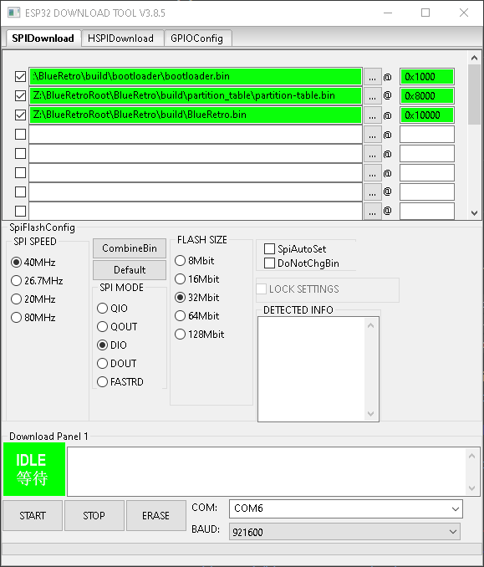
5. Select proper COM port for your machine.
6. Press START (If the flash does not start hold the EN button to start the process)
7. Wait for status to change to FINISH.

Clearing Flash memory:

If the flash is failing or the firmware is corrupt and will not recover you can erase the flash memory.

1. Open Powershell
   1. Make sure that python is installed
   2. *python –version*
      1. if python is not installed, go to the window store, search for python and install 3.91
   3. Install esptool
      1. *pip install esptool*
   4. Clear Flash
      1. *esptool.py --chip esp32 --port comX erase_flash*
         1. comX will be the com port on your machine
2. Once complete, retry ESP flash tool